**LAdemy**

**LAdemy** is a famous online course platform used by many students and professionals all over the world. Because of its increasing popularity, it is getting harder to handle the transaction data. You are asked to help **LAdemy** managing their database transaction.

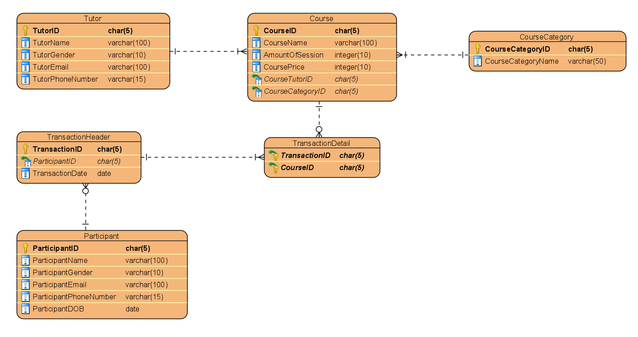

1. Create a database named “**lademy_subscription**”

(**CREATE DATABASE**)

1. Create a table named “**subscription**” with the following descriptions.

(**CREATE TABLE**)

|  |  |  |  |
| --- | --- | --- | --- |
| Field Name | Data Type | Length | Description |
| SubscriptionID | CHAR | 5 | **Primary Key**. **SubscriptionID** must be started with ‘SC’ and followed by 3 digits number.  Example: SC001 |
| ParticipantID | CHAR | 5 | References from **Participant.** If the referenced data is changed then the changes will be cascaded. |
| StartSubscription | DATE |  | Not Null |
| EndSubscription | DATE |  | **EndSubscription** date must be at least **30 day after** the **StartSubscription** date. |

1. Create a table named “**membership**” with the following descriptions.

(**CREATE TABLE**)

|  |  |  |  |
| --- | --- | --- | --- |
| Field Name | Data Type | Length | Description |
| MembershipID | CHAR | 5 | **Primary Key**. **MembershipID** must be started with ‘ME’ and followed by 3 digits number.  Example: ME001 |
| ParticipantID | CHAR | 5 | Not Null |
| MemberPoint | INT |  | MemberPoint must be **even number**. |
| JoinDate | DATE |  | JoinDate year must be before **2023**. |

1. **Insert** these data into **subscription** and **membership** table.

(**INSERT**)

|  |  |  |  |
| --- | --- | --- | --- |
| **Subscription** | | | |
| SubscriptionID | ParticipantID | StartSubscription | EndSubscription |
| SC001 | PT006 | 2021-05-09 | 2021-07-09 |
| SC002 | PT001 | 2021-08-10 | 2022-01-10 |
| SC003 | PT009 | 2022-01-05 | 2022-03-05 |

|  |  |  |  |
| --- | --- | --- | --- |
| **Membership** | | | |
| MembershipID | ParticipantID | MemberPoint | JoinDate |
| ME001 | PT004 | 12 | 2021-08-02 |
| ME002 | PT007 | 6 | 2022-02-05 |
| ME003 | PT005 | 20 | 2022-04-07 |

1. Display **CourseName**, **CourseCategoryName**, and **CoursePrice** (obtained by adding ‘Rp ’ before CoursePrice) for every course which have **at least 10 sessions**.

(**CONCAT, JOIN**)

`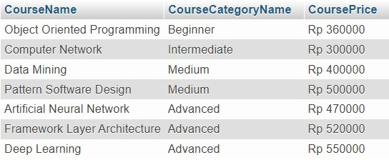

1. Display **ParticipantName**, **TransactionDate** (obtained from TransactionDate in ‘DD MM YYYY’ format), and **CourseName** for every course which **CourseName** has **more than 20 characters** and the **last digit of CourseID** is **even number**.

(**DATE_FORMAT**, **LENGTH**, **RIGHT**)

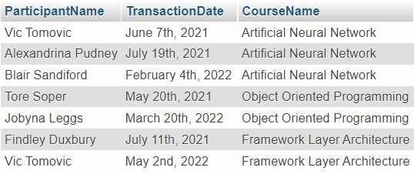

1. Display **ParticipantName** (obtained from participant first name), **ParticipantEmail**, **ParticipantGender**, **TransactionDate**, and **MemberPoint** for every participant which have **transaction on June** and have **MemberPoint more than 15**.

(**SUBSTR**, **MONTH**)



1. Update **TutorEmail** to **ends with** ‘lademy.co.id’ for every tutor which are teaching a course in category **CRT04**.

(**UPDATE**, **CONCAT**)

Before Update:

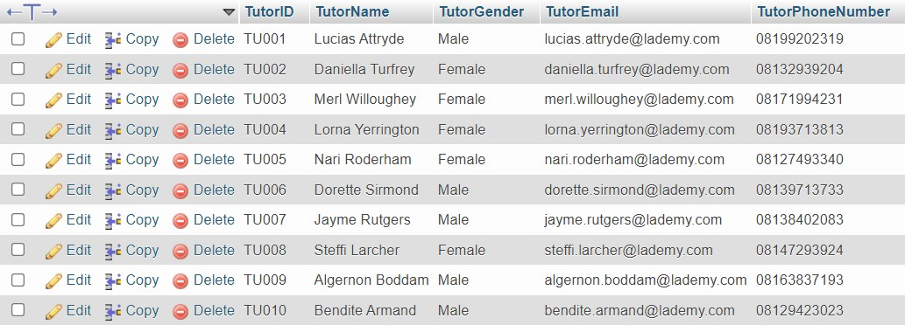

After Update:

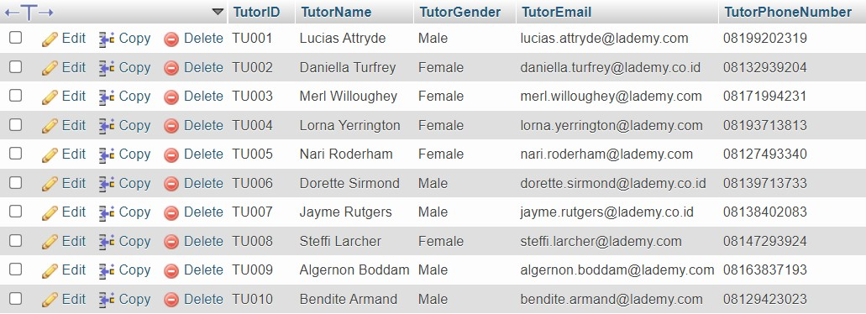

1. Delete participant data which have a transaction on **Sunday**.

(**DELETE, DAYNAME**)

Before Update:

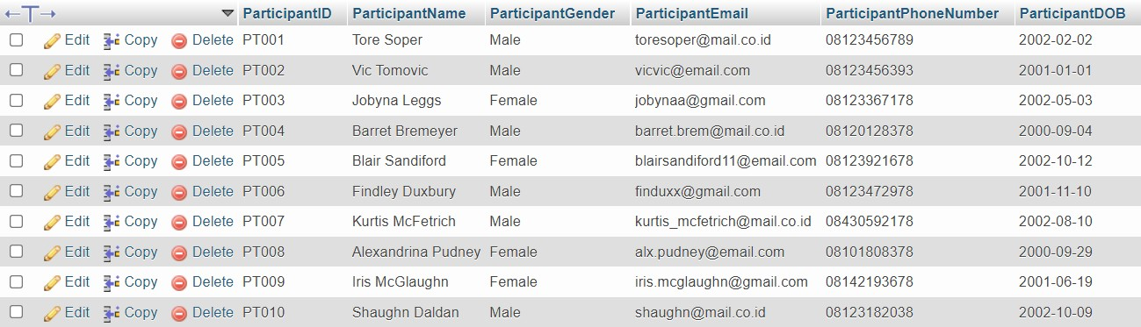

After Update:

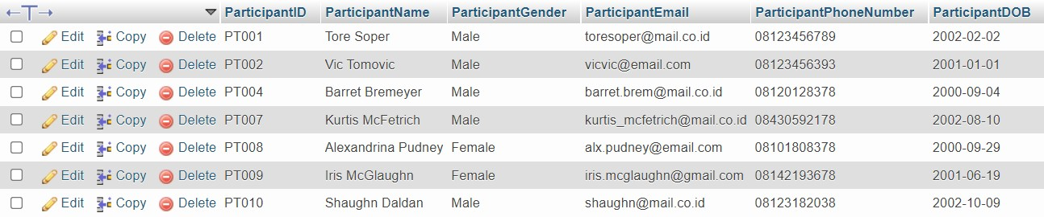

1. Delete **lademy_subscription** database.

(**DROP DATABASE**)